Project Design Phase-II Technology Stack (Architecture & Stack)

|  |  |
| --- | --- |
| Team ID | PNT2022TMID50449 |
| Project Name | Project - Real-Time Communication System Powered by AI for Specially Abled |
| Maximum Marks | 4 Marks |

Technical Architecture:

The Deliverable shall include the architectural diagram as below and the information as per the table1 & table 2

Example: Real-Time Communication System Powered by AI for Specially Abled

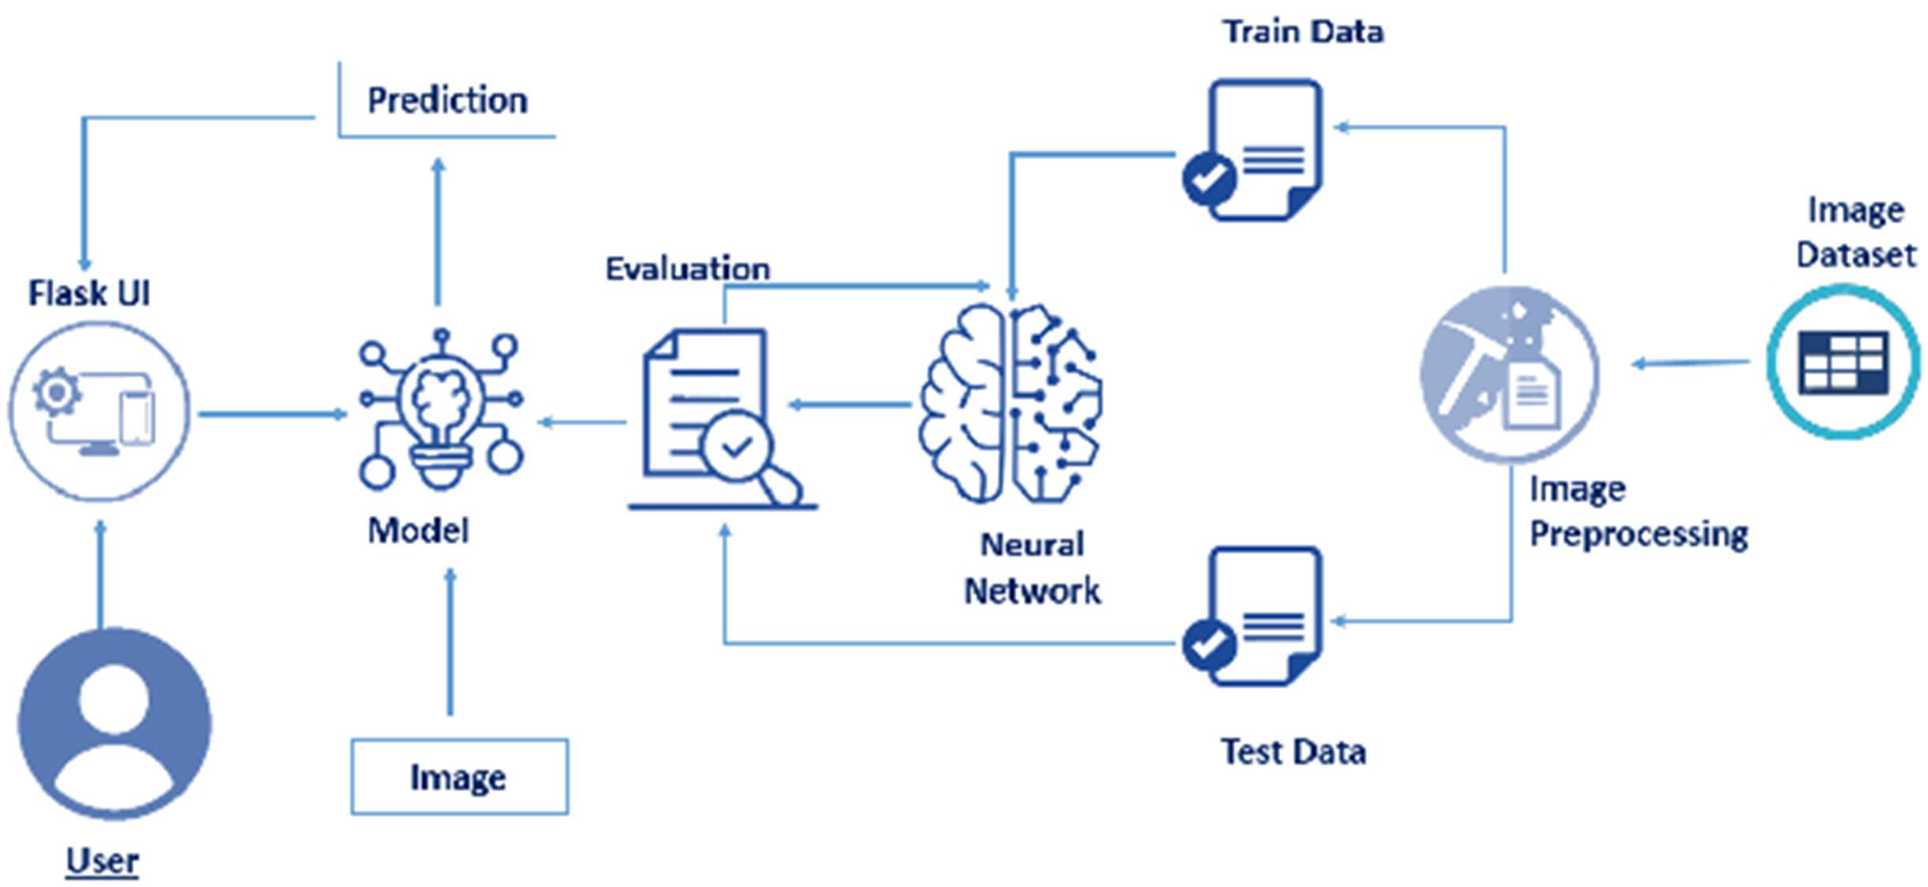

Table-1 : Components & Technologies:

|  |  |  |  |
| --- | --- | --- | --- |
| **S.No** | **Component** | **Description** | **Technology** |
| 1. | User | Deaf and dumb people willing to communicate efficiently, without any hassle with others in their  surrounding environment | AI techniques |
| 2. | Flask UI | The components of Flask’s User Interface allow one to interact with clients that make use of your  application and gather information. | Can be executed using existing cloud technologies |
| 3. | Image Dataset | The initial prototype of this application is trained on  a subset of the dataset containing 20 different signs adhering to the American Sign Language | AI techniques |
| 4. | Image Preprocessing | The images in the dataset are preprocessed to increase the sharpness / clarity and remove any noise | ANN, CNN, OpenCV |
| 5. | Training | SVM is run on the training dataset to extract attributes from the images which are then fed to the Neural Network in order to make the prediction | Scikit-learn, Natural Language Processing (NLP) |
| 6. | Testing | The trained model is then run on an additional untested 10-15 sign-language images and the performance parameters are evaluated and recorded | Scikit-learn, NLP |
| 7. | Neural Network | The same neural network architecture is used for  both top-view and bottom-view models; the only difference lies in the number of output units | ANN |
| 8. | Evaluation | Records the generalization accuracy of the proposed model on future / unseen data |  |
| 9. | Model | ML algorithms like SVM (Support Vector Machine) are applied to classify the given image dataset | Machine Learning |
| 10. | Prediction | The attributes extracted from the images are examined and predictions are made in order to convert the sign-language to the corresponding text | ANN, CNN |

Table-2: Application Characteristics:

|  |  |  |  |
| --- | --- | --- | --- |
| **S.No** | **Characteristics** | **Description** | **Technology** |
| 1. | Open-Source Frameworks | Robots and various other AI tools have made it  possible for people with disabilities to live comfortably | AI techniques like self-moving robots and other software systems |
| 2. | Security Implementations | Users are authenticated based on their username/password pair and/or OTP sent to their given mobile numbers | SHA-1, Encryptions, IAM Controls |
| 3. | Scalable Architecture | We implement a modular 3-tier client-server application architecture that improves scalability, availability, and performance. Individual tiers are containerized | Presentation layer, Application layer and Data Layer modularity, Docker |
| 4. | Availability | The application has an extremely low downtime and load balancers forward request to other available machines in case of failures | Key performance indicators (KPI) |
| 5. | Performance | The application performs efficiently under a heavy  load of translation requests without any significant reduction in the conversion accuracy | Number of requests per minute,  accuracy of translation (sign-language to speech & text to sign-language) |